Two different approaches are given at the current document/section:

* Monthly-based data analysis (most common application of Option C).
* Hourly-based data analysis (increasing use with use of time-of-use and smart meters)

I. Monthly-based data case studies

CASE A.- OPTION C.- Several ECMs in a Commercial Mall

**1. Situation**

This project involves the implementation of a package of various ECMs in a mall:

* Replacement of lighting in different areas
* Various improvements in the HVAC of common spaces
* Set schedule control system

The savings expected from the project is 27% of energy consumption reference.

The user requires the use of option C, the ESCO who develops the project agree and the characteristics of the project are favorable to this approach (large quantity of savings expected, potential existence of interactive effects between ECMs, etc).

In the next table are provided several data available for the baseline period.

| *Month* | *Consumption (kWh)* | *Days* | *Occupnacy (Asist./month)* | *Average Temp (ºC)* | *RH (%)* | *Wind speed (m/s)* | *Solar radiation (MJ/m2)* | *Eto (mm)* |
| --- | --- | --- | --- | --- | --- | --- | --- | --- |
| *jan-12* | *579.651* | *30* | *1.006.401,00* | *3,89* | *76,90* | *1,50* | *8,84* | *33,19* |
| *feb-12* | *594.073* | *29* | *654.359,00* | *4,08* | *51,74* | *2,73* | *12,92* | *61,47* |
| *mar-12* | *564.725* | *31* | *680.281,00* | *10,28* | *50,88* | *1,86* | *17,71* | *95,94* |
| *apr-12* | *496.578* | *30* | *679.402,00* | *11,11* | *63,92* | *2,97* | *17,92* | *99,69* |
| *may-12* | *572.999* | *31* | *671.193,00* | *17,94* | *53,77* | *1,77* | *24,66* | *154,58* |
| *jun-12* | *614.323* | *30* | *672.679,00* | *23,17* | *40,79* | *1,85* | *26,73* | *185,75* |
| *jul-12* | *687.538* | *31* | *752.889,00* | *24,09* | *40,15* | *1,45* | *28,89* | *196,71* |
| *aug-12* | *684.956* | *31* | *633.692,00* | *24,89* | *39,58* | *1,59* | *24,00* | *178,89* |
| *sep-12* | *560.727* | *30* | *667.995,00* | *19,61* | *52,87* | *1,46* | *17,21* | *103,80* |
| *oct-12* | *504.948* | *31* | *740.113,00* | *13,88* | *73,32* | *1,14* | *13,06* | *58,07* |
| *nov-12* | *537.085* | *30* | *761.291,00* | *8,98* | *80,53* | *1,13* | *7,11* | *26,55* |
| *dec-12* | *636.226* | *31* | *1.016.147,00* | *5,21* | *83,97* | *1,51* | *5,96* | *23,04* |
| *jan-13* | *623.013* | *30* | *972.843,00* | *4,54* | *79,34* | *2,05* | *7,09* | *27,43* |
| *feb-13* | *553.987* | *28* | *624.314,00* | *5,65* | *69,02* | *2,51* | *10,51* | *45,73* |
| *mar-13* | *563.895* | *31* | *737.934,00* | *8,74* | *75,67* | *2,49* | *11,72* | *60,98* |
| *abr-13* | *515.410* | *30* | *654.375,00* | *11,40* | *65,32* | *2,44* | *19,42* | *96,01* |
| *may-13* | *498.257* | *31* | *707.727,00* | *13,57* | *62,04* | *1,84* | *24,13* | *131,50* |
| *jun-13* | *571.834* | *30* | *713.490,00* | *20,38* | *45,29* | *2,21* | *28,07* | *189,12* |
| *jul-13* | *697.448* | *31* | *816.359,00* | *25,66* | *38,30* | *1,80* | *27,62* | *210,20* |
| *aug-13* | *679.146* | *31* | *665.028,00* | *24,64* | *40,73* | *1,71* | *24,25* | *183,75* |
| *sep-13* | *599.502* | *30* | *681.026,00* | *20,27* | *53,30* | *1,56* | *19,07* | *122,15* |
| *oct-13* | *508.782* | *31* | *719.023,00* | *14,79* | *72,70* | *1,37* | *12,52* | *67,52* |
| *nov-13* | *529.013* | *30* | *789.645,00* | *7,79* | *70,96* | *2,12* | *8,61* | *45,17* |
| *dec-13* | *618.030* | *31* | *1.068.260,00* | *3,68* | *77,80* | *1,64* | *7,57* | *27,99* |
| Table 4.- Baseline data. CASE A | | | | | | | | |

2. M&V Option selected

Option C Whole Building was selected for quantifying the electric energy savings for this building. The M&V plan describes the procedures and uncertainty analysis for the electric savings based on the monthly energy use data. Because the energy efficiency projects affect both the lighting and HVAC systems, and have a high degree of interaction, the measurement boundary for the project was selected as whole building so that all energy using systems in the building were included. Activities and issues addressed in the M&V Plan include the following:

* The plan will be IPMVP-adherent, Option C.
* The electricity supplier meters will be used for calculations during reporting period, as well as for the equations for baseline adjustments. Additional meters are available at the same point of those of the energy supplier, for their use in case of failure.
* The primary influences of the building’s energy use were ambient temperature and occupancy, due to the elevated charge of heating/cooling needs.
* The owner wants to know the energy savings of the project as follows:
  + 5 years of reporting period.
  + Use of “avoided energy/cost” approach.

3. Assumptions

* The range of data in the baseline period is sufficient to capture the behavior of energy use by covering tow natural years.
* The data used in the development of baseline energy model are normally distributed and show no autocorrelation.
* Building occupancy range is properly covered with the baseline data.

4. Sources of Error

5. Statistical analysis

The analysis of this case, as usual begins, performing an exploratory analysis of each of the variables considered.

Since the total monthly energy consumption clearly depends on the number of days in month, this analysis has been chosen as the response variable using the average consumption per day, dividing the total monthly consumption for the days that make up each month.

The graph of next figure shows a marked seasonal component in the series of energy consumption. The average daily electricity consumption presents a very marked cyclical behavior. Important consumption peaks are observed during the months of July and August and during the coldest months December, January and February.

|  |
| --- |
| Macintosh HD:Users:fcrespo:Dropbox:EMIN:caso3.1.jpeg |
| Fig. 2.- Energy consumption vs time |

5.1. Scatter plots of all variables. Progressive elimination of variables

First of all we proceed to evaluate the eventual relationships between all the independent variables available.

|  |
| --- |
| scatter-matrix.bmp |
| Fig. 3.- Scattering/correlation matrix for all variables of CASE A |

From this point we’ll try to find the best multi-variable linear model by linear regression analysis of all variables, and a progressive analysis approach consisting in eliminate, step by step, the variables less significant.

So,

* **Model 1**

The model we propose is as follows:

* Variable response:
  + Average daily consumption: kWh (month)/days per month
* Explanatory variables:
  + Days (of the energy period)
  + Occupancy
  + Temperature
  + RH (relative humidity)
  + Windspeed
  + Radiation
  + CWSI

Equation:

Developing the linear regression analysis on software “R” we obtain the following results:

Call:

lm(formula = energy.d ~ days + occupancy + temperature + RH +

windspeed + radiation + CWSI)

Residuals:

Min 1Q Median 3Q Max

-1978.21 -510.17 -88.52 819.47 1563.69

Coefficients:

Estimate Std. Error t value Pr(>|t|)

(Intercept) 4.406e+04 1.139e+04 3.867 0.00136 **

days -6.159e+02 3.893e+02 -1.582 0.13316

occupancy 6.331e-03 3.564e-03 1.777 0.09465 .

temperature -1.469e+02 1.566e+02 -0.938 0.36204

RH -9.933e+01 4.802e+01 -2.068 0.05517 .

windspeed -6.022e+02 8.651e+02 -0.696 0.49632

radiation -6.761e+02 2.114e+02 -3.198 0.00560 **

CWSI 9.564e+01 4.209e+01 2.272 0.03722 *

---

Signif. codes: 0 ‘***’ 0.001 ‘**’ 0.01 ‘*’ 0.05 ‘.’ 0.1 ‘ ’ 1

Residual standard error: 1041 on 16 degrees of freedom

Multiple R-squared: 0.8042, Adjusted R-squared: 0.7185

F-statistic: 9.388 on 7 and 16 DF, p-value: 0.0001191

Table 6.- Results of linear regression analysis. CASE A. Model 1 results

The less significant variable is “windspeed”, so we repeat the analysis without this variable.

* **Model 2**

The model we propose is as follows:

* Variable response:
  + Average daily consumption: kWh (month)/days per month
* Explanatory variables:
  + Days (of the energy period)
  + Occupancy
  + Temperature
  + RH (relative humidity)
  + ~~Windspeed~~
  + Radiation
  + CWSI
* Equation:

Developing the linear regression analysis on software “R” we obtain the following results:

Call:

lm(formula = energy.d ~ days + occupancy + temperature + RH +

radiation + CWSI)

Residuals:

Min 1Q Median 3Q Max

-2032.16 -508.27 17.18 758.82 1621.13

Coefficients:

Estimate Std. Error t value Pr(>|t|)

(Intercept) 3.994e+04 9.590e+03 4.165 0.000648 ***

days -5.464e+02 3.705e+02 -1.475 0.158547

occupancy 7.827e-03 2.799e-03 2.796 0.012410 *

temperature -6.144e+01 9.568e+01 -0.642 0.529345

RH -1.101e+02 4.476e+01 -2.460 0.024898 *

radiation -6.144e+02 1.890e+02 -3.251 0.004705 **

CWSI 7.783e+01 3.291e+01 2.365 0.030200 *

---

Signif. codes: 0 ‘***’ 0.001 ‘**’ 0.01 ‘*’ 0.05 ‘.’ 0.1 ‘ ’ 1

Residual standard error: 1025 on 17 degrees of freedom

Multiple R-squared: 0.7983, Adjusted R-squared: 0.7271

F-statistic: 11.21 on 6 and 17 DF, p-value: 4.13e-05

Table 7.- Results of linear regression analysis. CASE A. Model 2 results

Now the less significant variable is “temperature”, so we repeat the analysis without this variable.

* **Model 3**

The model we propose is as follows:

* Variable response:
  + Average daily consumption: kWh (month)/days per month
* Explanatory variables:
  + Days (of the energy period)
  + Occupancy
  + ~~Temperature~~
  + RH (relative humidity)
  + ~~Windspeed~~
  + Radiation
  + CWSI
* Equation:

Developing the linear regression analysis on software “R” we obtain the following results:

Call:

lm(formula = energy.d ~ days + occupancy + RH + radiation + CWSI)

Residuals:

Min 1Q Median 3Q Max

-1946.72 -538.50 -51.01 837.79 1526.45

Coefficients:

Estimate Std. Error t value Pr(>|t|)

(Intercept) 4.182e+04 8.983e+03 4.656 0.000197 ***

days -6.330e+02 3.394e+02 -1.865 0.078541 .

occupancy 8.788e-03 2.327e-03 3.777 0.001381 **

RH -1.173e+02 4.263e+01 -2.752 0.013129 *

radiation -5.437e+02 1.511e+02 -3.598 0.002058 **

CWSI 6.230e+01 2.195e+01 2.838 0.010916 *

---

Signif. codes: 0 ‘***’ 0.001 ‘**’ 0.01 ‘*’ 0.05 ‘.’ 0.1 ‘ ’ 1

Residual standard error: 1008 on 18 degrees of freedom

Multiple R-squared: 0.7934, Adjusted R-squared: 0.736

F-statistic: 13.82 on 5 and 18 DF, p-value: 1.244e-05

Table 8.- Results of linear regression analysis. CASE A. Model 3 results

Now the less significant variable is “days”, so we repeat the analysis without this variable.

* **Model 4**

The model we propose is as follows:

* Variable response:
  + Average daily consumption: kWh (month)/days per month
* Explanatory variables:
  + ~~Days (of the energy period)~~
  + Occupancy
  + ~~Temperature~~
  + RH (relative humidity)
  + ~~Windspeed~~
  + Radiation
  + CWSI
* Equation:

$$Energy per day \left(kWh\right)=β_{0}+β_{1}∙occupancy+β_{2}∙RH+ β_{3}∙radiation+ β_{4}∙CWSI+ ε$$

Developing the linear regression analysis on software “R” we obtain the following results:

Call:

lm(formula = energy.d ~ occupancy + RH + radiation + CWSI)

Residuals:

Min 1Q Median 3Q Max

-1906.90 -693.08 -1.44 585.27 2194.03

Coefficients:

Estimate Std. Error t value Pr(>|t|)

(Intercept) 2.612e+04 3.331e+03 7.841 2.26e-07 ***

occupancy 7.493e-03 2.361e-03 3.173 0.00501 **

RH -1.441e+02 4.267e+01 -3.377 0.00317 **

radiation -5.365e+02 1.606e+02 -3.339 0.00345 **

CWSI 5.197e+01 2.259e+01 2.301 0.03290 *

---

Signif. codes: 0 ‘***’ 0.001 ‘**’ 0.01 ‘*’ 0.05 ‘.’ 0.1 ‘ ’ 1

Residual standard error: 1072 on 19 degrees of freedom

Multiple R-squared: 0.7534, Adjusted R-squared: 0.7015

F-statistic: 14.51 on 4 and 19 DF, p-value: 1.365e-05

Table 9.- Results of linear regression analysis. CASE A. Model 4 results

Now all the variables included are significant (p<0.05), but the model obtained could be improved by further analysis.

5.2. Change Point Model

Since most of the energy consumption occurs due to the demand of heating and cooling, the explanatory variable that focuses our attention in this study is the average temperature of each month.

Another explanatory variable we considered in the study was the Occupation variable that measures the number of people who have come monthly to the mall.

Next figure shows scatterplots of consumption versus average temperature and against the occupation by day. In these graphs a clearer relationship between consumption and temperature shows that between consumption and occupation.

|  |
| --- |
| Macintosh HD:Users:fcrespo:Dropbox:EMIN:caso3.2.jpeg |
| Fig. 4.- Scatter plots with Lowess curve, for Energy Vs Temperature and Energy Vs Occupancy |

Energy consumption decreases with increasing temperature to 15 ° C, and then increases linearly for temperatures above this value. The value of 15 ° C is therefore a turning point for the linear regression model we propose later.

Another option would be to obtain a model without changing points where consider a quadratic effect of temperature.

Next figure shoes scatterplots of average energy consumption per day compared to other meteorological variables that measure characteristics such as relative humidity, and wind speed, among other shows.

|  |
| --- |
| Macintosh HD:Users:fcrespo:Dropbox:EMIN:caso3.3.jpeg |
| Fig. 5.- Scatter plots with Lowess curve, for Energy Vs RH; Energy Vs Windspeed; Energy Vs radiation and Energy Vs CWSI |

Noting these diagrams, the variable less correlated with energy consumption seems to be the wind speed. In other cases, the consumption of energy presents a quadratic relationship with the other meteorological variables considered. This U-shaped pattern, is similar in all three cases because these variables are linearly related (high values of some variables are associated with high values of the other, and vice versa).

The models can not include these variables simultaneously, as would present a problem of multicollinearity.

The model we propose is a regression model with a turning point where energy consumption depends on temperature. This model also includes a binary variable that differentiates the coldest months (December, January, February and March).

Response variable:

* Energy consumption: average daily energy consumption per month (kWh/days·month)

Explicative variables:

* Temperature: monthly average temperature (ºC)
* D: binary variable. D = 0 for temperatures below 15 ° C and D = 1 for temperatures above 15 ° C
* Season: binary variable. Season = 0 for the colder months (December, January, February and March), and Season = 1 for the remaining months.

Equation of the proposed model:

$$Average dayly consumption= β_{0}+β_{1}·Temperature+β_{3}·D·(Temperature-15)+β_{4}·season+ε$$

The results obtained are shown below after adjusting the model to the data:

Call:

lm(formula = energy.d ~ temperature + t15 + season)

Residuals:

Min 1Q Median 3Q Max

-836.66 -307.51 -73.14 342.36 784.42

Coefficients:

Estimate Std. Error t value Pr(>|t|)

(Intercept) 21209.72 345.32 61.421 < 2e-16 ***

temperature -270.27 51.62 -5.236 4.01e-05 ***

t15 889.79 76.21 11.676 2.20e-10 ***

season -1130.46 409.79 -2.759 0.0121 *

---

Signif. codes: 0 ‘***’ 0.001 ‘**’ 0.01 ‘*’ 0.05 ‘.’ 0.1 ‘ ’ 1

Residual standard error: 497 on 20 degrees of freedom

Multiple R-squared: 0.9442, Adjusted R-squared: 0.9358

F-statistic: 112.7 on 3 and 20 DF, p-value: 1.06e-12

Table 10.- Results of linear regression analysis. CASE A. Model with one turning point.

The p value associated with the F test is very low p-value = 1,06 E-12. This indicates that the model is significant, ie that at least one of the explanatory variables considered is useful to predict the average energy consumption.

All model parameters are also significant to a level of significance of 5% (p<0.05).

This model features a high degree of goodness of fit: R ^ 2 = 0.9442, standard error of the regression model is s = 497 kWh and has 20 degrees of freedom associated.

The next step we must consider is the validation of the linear regression hypothesis (linearity, independency, normality and homocedasticity).

We proceed to validate this model by residual plots presented in next figure.

|  |
| --- |
| Macintosh HD:Users:fcrespo:Dropbox:EMIN:caso3.4.jpeg |
| Fig. 6.- Graphics of residuals of the model |

Noting residual plots any anomaly that clearly prevents us take for valid the proposed model is observed.

The Durbin-Watson test gives a p-value of 0.8537, which confirms that the model errors present no problems for first-order autocorrelation.

$$Daily energy \left(kWh/days\right)= 21.209,72-270,27·Temperature \left(ºC\right)+889,79·D*\left(Temperature-15\right)-1.130,46·Season$$

NOTE: remember that “D” and “Season” in the above expression are binary variables with the values specified above.

Let us finally to verify compliance of the 3 specific criteria recommended by the IPMVP:

* **R2 > 0,75** The value of R2 of the model is much higher (R2 = 0.9442). **Compliant**
* **CV < 0,2 (0,05 recommended)** The value obtained by the model is less (CV = 0,026). **Compliant**

$${CV}_{RMSE}=\frac{{SE}_{\hat{Y}}}{\overline{Y}}=\frac{497}{19.193,61}=0,026$$

The mean value of Y corresponds to the average of the daily average energy consumption per month.

* **Bias < 0,005%** To check the bias has been made model predictions according to the rounding of the coefficients discussed above, comparing these predictions with the observed values for the reference period. This test has been completed using a spreadsheet, which do not add to this paragraph to not unnecessarily load the same.  
  Tested with the spreadsheet we see that fulfills the criterion of bias, even if the number of digits of the coefficients set forth in the selected formula.  
  **Compliant**

This model is, therefore, we use the model to make predictions. The following table presents the predictions for the average consumption of electricity, along with the intervals for the same, obtained with a confidence of 95%, for different temperatures and different types of month (cold and not so cold months):

|  |  |  |  |  |
| --- | --- | --- | --- | --- |
| Average temp (ºC) | Type of month | Predicted daily energy consumption (kWh) | Intervals of confidence for the values predicted at 95% | |
| Inferior limit (kWh) | Superior limit (kWh) |
| 5 | Cold | 19858 | 19483 | 20234 |
| 10 | Cold | 18507 | 17921 | 19093 |
| 15 | Warm | 16025 | 15542 | 16508 |
| 20 | Warm | 19123 | 18830 | 19415 |
| 25 | Warm | 22220 | 21762 | 22678 |
| Table 11.- Intervals of confidence for predictions. | | | | |

5.3. Comparison with a quadratic model

Nevertheless, we proceed to compare the previous model with a quadratic model in order to see what are their respective SE.

Response variable:

* Energy consumption: average daily energy consumption per month (kWh/days·month)

Explicative variables:

* Temperature: monthly average temperature (ºC)
* Temperature - square: temperature values to the square

Equation of the proposed model:

$$Average dayly consumption= β_{0}+β_{1}·Temperature+β_{3}·Temperature^2+ε$$

The results obtained are shown below after adjusting the model to the data:

Call:

lm(formula = energy.d ~ temperature + temperature.2)

Residuals:

Min 1Q Median 3Q Max

-1131.86 -566.54 69.28 532.00 1076.99

Coefficients:

Estimate Std. Error t value Pr(>|t|)

(Intercept) 23908.488 562.993 42.47 < 2e-16 ***

temperature -1040.475 93.883 -11.08 3.11e-10 ***

temperature.2 39.157 3.184 12.30 4.63e-11 ***

---

Signif. codes: 0 ‘***’ 0.001 ‘**’ 0.01 ‘*’ 0.05 ‘.’ 0.1 ‘ ’ 1

Residual standard error: 669.2 on 21 degrees of freedom

Multiple R-squared: 0.8937, Adjusted R-squared: 0.8836

F-statistic: 88.3 on 2 and 21 DF, p-value: 5.991e-11

Table 12.- Results of linear regression analysis. CASE A. Square model using temperature as the unique independent variable.

The residual standard error of the quadratic model is equal to 669.5, and whereas that the standard error of the one point-change model is 497, so we will validate the previous model as the equation to make the Baseline adjustments during the reporting period (RP).

6. Savings and Uncertainty

* $Model$ proposed
$$Energy \left(kWh/days\right)= 21.209,72-270,27·Temperature \left(ºC\right)+889,79·D*\left(Temperature-15\right)-1.130,46·Season$$

* ${SE}_{\hat{Y}}$ = 497
* $t_{α/2,gl}$ = 1,724718
  + Level of confidence: 90%,
  + Degrees of freedom: 20
* n = 12 / 60 (we calculate the uncertainty associated to one year and the entire reporting period, five years).
* Expected savings per year = 1.888.939,44 kWh
  + (1.888.939,44/365) x 12 = $62.102,12$

We know that for calculate the uncertainty of the mathematical model (expressed in percentage) we should use the following equation:

$$u\left(\%\right)=\frac{t_{α/2,gl}∙\sqrt{{{n∙SE}_{\hat{Y}}}^{2}}}{expected savings for the period}×100$$

So, if we introduce into the equation the previous data, the relative uncertainties of the model are:

$$u\left(\%\right) for 1 PD years=\frac{1,724718∙\sqrt{{12∙497}^{2}}}{62.102,12}×100=±4,8\% (n.c.=90\%)$$

$$u\left(\%\right) for 5 PD years=\frac{1,724718∙\sqrt{{60∙497}^{2}}}{310.510,6}×100=±2,14\% (n.c.=90\%)$$

We can see that in this case the final expected uncertainty of the model proposed is better than the initial goal value (7% for 90% l.c.).

6.1 Uncertainty during the Reporting period

In the next table are shown the values of the independent variables during the reporting period, as well of those of the observed energy consumption and the calculated savings with their uncertainty values.

|  |  |  |  |  |  |  |  |  |  |  |  |  |
| --- | --- | --- | --- | --- | --- | --- | --- | --- | --- | --- | --- | --- |
|  | Reporting period variables | | | Baseline adjusted (Energy/day) (kWh/day) | | | Reporting period (Energy/day) (kWh/day | Energy avoided (Energy/day) (kWh/day) | | | | Monthly Savings Uncertainty |
| Month | Season | Temperature | D | Fit | Lower interval | Upper interval | Observed during RP | Savings (fitted values) | Upper int. | Lower int. | Savings |
| ene-14 | 0 | 7,23 | 0 | 19256 | 18925 | 19586 | 13423 | 5833 | 5502 | 6163 | 30% | 5,67% |
| feb-14 | 0 | 6,62 | 0 | 19421 | 19108 | 19733 | 14152 | 5269 | 4956 | 5581 | 27% | 5,93% |
| mar-14 | 0 | 9,96 | 0 | 18518 | 18036 | 18999 | 13147 | 5371 | 4889 | 5852 | 29% | 8,96% |
| abr-14 | 1 | 14,99 | 0 | 16028 | 15629 | 16427 | 11558 | 4470 | 4071 | 4869 | 28% | 8,93% |
| may-14 | 1 | 17,17 | 1 | 17370 | 17065 | 17674 | 12832 | 4538 | 4233 | 4842 | 26% | 6,71% |
| jun-14 | 1 | 21,52 | 1 | 20064 | 19810 | 20319 | 13998 | 6066 | 5812 | 6321 | 30% | 4,20% |
| jul-14 | 1 | 23,38 | 1 | 21217 | 20908 | 21526 | 14980 | 6237 | 5928 | 6546 | 29% | 4,95% |
| ago-14 | 1 | 24,08 | 1 | 21650 | 21313 | 21988 | 15741 | 5909 | 5572 | 6247 | 27% | 5,71% |
| sep-14 | 1 | 20,36 | 1 | 19346 | 19104 | 19588 | 14556 | 4790 | 4548 | 5032 | 25% | 5,05% |
| oct-14 | 1 | 16,11 | 1 | 16713 | 16365 | 17061 | 12453 | 4260 | 3912 | 4608 | 25% | 8,17% |
| nov-14 | 1 | 10,37 | 0 | 17277 | 16938 | 17615 | 12206 | 5071 | 4732 | 5409 | 29% | 6,68% |
| dic-14 | 0 | 4,96 | 0 | 19869 | 19558 | 20180 | 13840 | 6029 | 5718 | 6340 | 30% | 5,16% |
| TOTAL |  |  |  | 226729 | 222759 | 230696 | 162886 | 63843 | 59873 | 67810 | 28% | 3,69% |

CASE B.- OPTION C.- Several ECMs in a heated pool

1. Situation

This case involves a draft M & V of different ECM implemented in a heated pool.

The pool has an energy meter for independent from the rest of the installation uses (lighting, bar-cafeteria, office automation equipment, etc) thermal installations.

The ECMs are:

* Replacement of existing simple glass enclosure by insulating glass enclosure.
* Incorporation of dehumidifier and energy recovery from this.
* Installation of solar thermal panels to support existing equipment.
* Installation of gas boilers for hot water heating and indoor air, replacing the existing electrical resistances partially used for these applications in the reference installation.

The energy savings expected by the ECM package is 60% of baseline energy consumption.

Following baseline data will be used to elaborate and validate the mathematical model of adjustment, as well as evaluating the uncertainty from that model..

| Month | Energy Consumption KWh | Days | Occupancy (monthly average) | HDD (º27 C) |
| --- | --- | --- | --- | --- |
| January | 32.810,00 | 31 | 157 | 530,1 |
| February | 33.250,00 | 28 | 154 | 504 |
| March | 28.407,00 | 31 | 151 | 443,3 |
| April | 20.216,00 | 30 | 150 | 354 |
| May | 18.111,00 | 31 | 145 | 269,7 |
| June | 14.949,00 | 30 | 147 | 168 |
| July | 8.607,00 | 31 | 139 | 46,5 |
| August | 6.772,00 | 31 | 125 | 27,9 |
| September | 7.544,00 | 30 | 142 | 75 |
| October | 12.682,00 | 31 | 148 | 179,8 |
| November | 21.276,00 | 30 | 146 | 375 |
| December | 26.441,00 | 31 | 149 | 471,2 |
| TOTAL | 231.065,00 | 365 |  | 3444,5 |
| Table 5.- Baseline data. CASE B | | | | |

2. M&V Plan. Option selected

We opt for a C option for the following reasons:

• High expected energy savings

• Existence of interactive effects between each of the ECM previews

• Convenience of this to the end customer

3. Assumptions

* The range of data in the baseline period is sufficient to capture the behavior of energy use by covering one natural year.
* The data used in the development of baseline energy model are normally distributed and show no autocorrelation.
* Building occupancy range and weather conditions are properly covered with the baseline data.

4. Sources of Error

5. Statistical analysis

We started the study by conducting an exploratory analysis of each of the variables considered.

|  |
| --- |
| Macintosh HD:Users:fcrespo:Dropbox:EMIN:caso4.1.jpeg |
| Fig. 7.- Energy consumption Vs time |

Next figure shows the temporal series for both explanatory variables (HDD and occupancy).

|  |
| --- |
| Macintosh HD:Users:fcrespo:Dropbox:EMIN:caso4.2.jpeg |
| Fig. 8.- HDD and Occupancy variables Vs time |

In the case of heating degree days, the appearance of the series is similar to the one with the response variable (energy consumption), whereas in the series that presents the number of attendees at the facility, catches the attention so abrupt decline that occurs in the month of August. This low value (125 people) is a value that is separated from the rest of the data to represent them in a box plot. This outlier is explained as the August holiday month for most pool users.

The next step will be to study the type of relationship that presents the response variable in this study (the average energy consumption per day) with each of the explanatory variables considered.

Next figure shows scatter plots versus consumption and heating degree days against the occupation. The graph on the left a fairly strong positive linear relationship between energy consumption and heating degree days is appreciated.

|  |
| --- |
| Macintosh HD:Users:fcrespo:Dropbox:EMIN:caso4.3.jpeg |
| Fig. 9.- Scatterplots and Lowess curve for EnergyVs HDD and Energy Vs Occupancy |

Notice in the graph on the right that the relationship between consumption and occupation is also an increasing linear relationship, and how a value that leaves the rest of the data and corresponds to the value that had previously detected in the temporal graph for the occupation variable.

Proposing a linear regression model to explain the power consumption in function of the two explanatory variables considered presents, in this case, a major problem, because the explanatory variables are strongly associated, as shown in the graph of next figure.

|  |
| --- |
| Macintosh HD:Users:fcrespo:Dropbox:EMIN:caso4.4.jpeg |
| Fig. 10.- Scatterplots for HDD Vs Occupancy |

It can be seen, again, the outlier which corresponds to an occupancy of 125 people for the month of August as a separate item on the rest of the data.

The coefficient of linear correlation of these two variables is r = 0.82, so that the degree of association of these variables is high. A regression model that includes both variables present problems of multicollinearity.

The solution is to ignore the study of one of these variables. We have chosen to discard the occupation variable, since the relationship between energy consumption and GDC Variable seemed clearer in the graphs above, and also because we avoid the problems that could result in adjusting the presence of an outlier like observed for the occupation variable.

* **Model 1**

The model we propose is as follows:

* Variable response:
  + Consumption: Monthly energy consumption (kWh)
* Explanatory variables:
  + HDD: monthly heating degree days (° C)
* Equation:

Monthly consumption (kWh) = β_0 + β_1 • HDD + ε  
  
The results obtained are shown below after adjusting the model to the data:

Residuals:

Min 1Q Median 3Q Max

-2427.1 -1394.6 176.4 1326.8 3023.9

Coefficients:

Estimate Std. Error t value Pr(>|t|)

(Intercept) 4740.932 1055.398 4.492 0.00116 **

hdd 50.566 3.133 16.138 1.73e-08 ***

---

Signif. codes: 0 ‘***’ 0.001 ‘**’ 0.01 ‘*’ 0.05 ‘.’ 0.1 ‘ ’ 1

Residual standard error: 1913 on 10 degrees of freedom

Multiple R-squared: 0.963, Adjusted R-squared: 0.9593

F-statistic: 260.4 on 1 and 10 DF, p-value: 1.729e-08

Table 13.- Results of linear regression analysis. CASE B. Model 1

The p value associated with the F test is very low p-value = 1.729 •〗 〖10 ^ (- 8). This indicates that the model is significant, ie that at least one of the explanatory variables considered is useful for predicting the monthly energy consumption. As the model only included as explanatory variables Variable GDC, this value p coincides with the p value associated with the β_1 parameter.

All model parameters are also significant to a level of significance of 5%.

This model features a high degree of goodness of fit: R 2 = 0.963. The standard error of the regression model is s = 1913 kWh and has 10 degrees of freedom associated.

Proceed to validate this model by residual plots presented in next figure:

|  |
| --- |
| Fig62.GraficosResidCaso4Modelo1.bmp |
| Fig. 11.- Graphics of residuals of the model |

Noting residual plots appreciate a problem of heteroscedasticity. The dispersion of the residuals is not constant but appears to increase the values increase as the explanatory variable HDD.

As shown in the graph of residues versus time, they present a problem of autocorrelation. We can confirm this by testing the significance of Durbin-Watson. The p value of the test is 0.016, this low value confirms that the model errors present problems of first order autocorrelation (the results of the test are significaticos for a significance level of 5%).

When working with variables that take only positive values, a possible solution is to transform the variables and work with the logarithm of the data.

The graph of next figure, is the scatter plot of the logarithm of the energy consumption compared to the HDD variable, which has been added a lowess curve. This graph is a strong positive linear relationship between the logarithm of the energy consumed and heating degree days is observed. The lowess curve also indicates a curvature in the relationship.

|  |
| --- |
| Fig63B.bmp |
|  |

* **Model 2**

The proposed model is therefore:

$$\log\left(Consumo mensual\right)= β_{0}+β_{1}·HDD +β_{2}·{HDD}^{2}+ε$$

The results obtained are shown below after adjusting the model to the data:

Residuals:

Min 1Q Median 3Q Max

-0.14515 -0.08410 0.00043 0.05319 0.18709

Coefficients:

Estimate Std. Error t value Pr(>|t|)

(Intercept) 8.758e+00 8.574e-02 102.154 4.19e-15 ***

hdd 4.394e-03 7.824e-04 5.616 0.000327 ***

hdd2 -2.523e-06 1.381e-06 -1.827 0.101044

---

Signif. codes:

0 ‘***’ 0.001 ‘**’ 0.01 ‘*’ 0.05 ‘.’ 0.1 ‘ ’ 1

Residual standard error: 0.1069 on 9 degrees of freedom

Multiple R-squared: 0.9706, Adjusted R-squared: 0.964

F-statistic: 148.5 on 2 and 9 DF, p-value: 1.284e-07

Table 14.- Results of linear regression analysis. CASE B. Model 2

The p value associated with β_0 and β_1 parameters are well below 0.05, so these parameters are clearly significant. The p value associated with the parameter is β_2 slightly above 5%, so it is not significant to a level of significance of 5%, but the value is close to this value. We decided not to remove this parameter model for this reason, and also because the determination coefficient corrected of the model that does not include that variable is R ̅ ^ 2 = 0.9572, so lower than the value of this statistic in the model considered (model 2).

The proposed model has a high degree of goodness of fit: R 2 = 0.9706 and the standard error of the regression model is s = 0.1069 log (kWh) and is associated with 9 degrees of freedom.  
  
Residual plots are shown in next figure.

|  |
| --- |
| F64b.bmp |
| Fig. 12.- Graphics of residuals |

This model does not seem to present problems of heteroskedasticity. The residuals form more or less a line in the graph quantile and the scatter plot of residuals versus time displayed, at least as clearly as in the previous model, a problem of autocorrelation.  
  
Significance testing Durbin-Watson presents, however, a p value = 0.039. This value indicates that the model errors still present a problem for first-order autocorrelation. Although the result of this test is significant, the value of the correlation coefficient first order of residuals takes a relatively low value, r_ (t, t-1) = 0.382, so that the effects of breach of this condition will not be severe, and the proposed model could be used for prediction of energy consumption, depending on the GDC.

However, when we try to check the bias obtained with this model, the obtained value exceeds by far the maximum recommended by ASHRAE Guideline14 (0.3% >>> 0.005%).  
  
Therefore, we will not use this model. The bias incorporated therein may result from conversion of monthly energy consumption to logarithms prior to regression analysis. To test this aspect, we will repeat the last regression analysis but without applying logarithms.

* **Model 3**

$$Energy (kWh)= β_{0}+β_{1}·HDD +β_{2}·{HDD}^{2}+ε$$

The results obtained are shown below after adjusting the model to the data:

Coefficients:

Estimate Std. Error t value Pr(>|t|)

(Intercept) 6.557e+03 1.385e+03 4.734 0.00107 **

hdd 2.831e+01 1.264e+01 2.240 0.05187 .

hdd2 4.030e-02 2.231e-02 1.806 0.10433

---

Signif. codes: 0 ‘***’ 0.001 ‘**’ 0.01 ‘*’ 0.05 ‘.’ 0.1 ‘ ’ 1

Residual standard error: 1727 on 9 degrees of freedom

Multiple R-squared: 0.9729, Adjusted R-squared: 0.9668

F-statistic: 161.3 on 2 and 9 DF, p-value: 8.937e-08

Table 15.- Results of linear regression analysis. CASE B. Model 3

The value of the parameter p β_0 is well below 0.05. The p value is near the value β_1 0.05, so these parameters are significant. The p value associated with the parameter is β_2 slightly above 5%, so it is not significant to a level of significance of 5%, but the value is close to this value (it is about 10%). We decided not to remove this parameter model for this reason, and also because the determination coefficient corrected model that does not include is R ̅ ^ 2 = 0.9572, so lower than the value of this statistic in the model considered .  
  
The proposed model has a high degree of goodness of fit: R 2 = 0.9729 and the standard error of the regression model is s = 1727 and has 9 degrees of freedom associated.  
  
The following figure shows residual plots.

|  |
| --- |
| F62b.bmp |
| Fig. 13.- Graphics of residuals of the model |

The graphics are similar to those obtained with the previous model, except that in this case perhaps a greater tendency for residual autocorrelation (residues vs time) to appreciate.  
  
We will check through statistical test both the autocorrelation as homocedastidicad data.  
  
As with the previous model, the significance test of Durbin-Watson has a p value = 0.039. This value indicates that the model errors still present a problem for first-order autocorrelation. Although the result of this test is significant, the value of the correlation coefficient of the first order residue takes a relatively low value, so that the effects of breach of this condition will not be serious, and the proposed model could be used to make predictions energy consumption, depending on the GDC.  
  
The tests undertaken to verify the heterodasticidad waste (Breusch-Pagan, Harrison-McCabe, Goldfeld-Quandt) tell us that there is no significant evidence of any such heterodasticidad, so we can assume that the hypothesis is true homocedasticity.  
  
Therefore, this is the model we use to make our predictions power consumption of the reference period adjusted:

$$Energy \left(kWh\right)= 6.557+28,31·HDD +0,0403·{HDD}^{2}+ε$$

The following table presents the predictions for the average consumption of electricity, along with the intervals for the same, obtained with a 95% confidence for different GDC:

|  |  |  |  |
| --- | --- | --- | --- |
| HDD base 27ºC (ºC) | Monthly energy consumption model prediction (kWh) | Interval of confidence for the prediction at 95% | |
| Límite inferior (kWh) | Límite superior (kWh) |
| 25 | 7290 | 4706 | 9873 |
| 50 | 8073 | 5931 | 10215 |
| 100 | 9791 | 8146 | 11436 |
| 200 | 13831 | 12035 | 15627 |
| 300 | 18677 | 16763 | 20592 |
| Table 16.- Intervals of confidence for predictions. | | | |

6. Savings and Uncertainty

$Model proposed$

$$Energy \left(kWh\right)= 6.557+28,31·HDD +0,0403·{HDD}^{2}+ε$$

* ${SE}_{\hat{Y}}$ = 1727
* $t_{α/2,gl}$ = 1,833
  + For a confidence level of 90%,
  + and 9 degrees of freedom
* n = 12 / 60 (we calcúlate the uncertainty associate for a year of RP and then for all the RP, 5 years).
* Expected level of savings per year = 138.639 kWh
  + Calculated from the energy consumption for one year of the Baseline = 231.065 kWh and
  + The expected percentage of savings: 60% in this case.
  + So, the expected savings for one year and for the entire RP are:
    - 1 year = 138.639 kWh
    - 5 years = 693.195 kWh

So, if we introduce into the equation the previous data, the relative uncertainties of the model are:

$$u\left(\%\right) for 1 year of RP=\frac{1,833∙\sqrt{{12∙1727}^{2}}}{138.639}×100=±7,9\% (n.c.=90\%)$$

$$u\left(\%\right) for 5 years of RP=\frac{1,833∙\sqrt{{60∙1727}^{2}}}{693.195}×100=±3,5\% (n.c.=90\%)$$

We can see that in this case the final expected uncertainty of the model proposed is better than the initial goal value (8% for 90% l.c.).

II. Hourly data case study

CASE C. Option C Whole Building using short time interval energy use data

1. Situation

In this example, multiple operational improvements were made in a university chemistry building as part of a retro-commissioning project. The improvements included:

* The constant volume chilled water, hot water, and air distribution systems were converted to variable volume, with the addition of variable frequency drives to fan and pump motors, and implementation of appropriate control algorithms.
* The legacy pneumatic control system was upgraded to a digital system, enabling HVAC systems to implement advanced control strategies, including:
  + Duct static pressure set point reset
  + Supply air temperature set point reset
  + Optimum start
* Over-ventilation in the buildings was reduced
* The T-12 fluorescent lighting systems were replaced with dimmable LED lamps. An advanced lighting controls system was also installed that enabled task lighting, scheduling, and daylight controls.
* Leaky pre-heat coils in air handling units were repaired, eliminating simultaneous heating and cooling.

These improvements were estimated to save 20% of annual electricity consumption. Many months prior to the start of the retro-commissioning project, a time-of-use (TOU) electric meter was installed to measure electric energy use at 15 minute intervals in the building. These measurements were recorded in a database.

This example will demonstrate how regression-based analysis based short-time interval energy use, ambient temperature, and a time-of-week variable may be used in an Option C approach to estimate the electric energy savings and uncertainty for this project.

2. M&V Option selected

The energy efficiency projects affect multiple systems within the building, and there is a high degree of interaction, therefore IPMVP Option C Whole Building was selected for quantifying the electric energy savings for this project. Six months of baseline period energy use data, measured at 15-minute intervals was available, and a year of savings was estimated under normalized conditions (normalized savings) after six months of post-installation energy use data was collected.

M&V Plan requirements and other considerations in selecting Option C include:

* Non-revenue grade whole-building electric meters were installed and calibrated eight months in advance of the comprehensive upgrade project, providing electric energy use data at 15 minute intervals. Metered data were collected for six months prior to the start of the implementation period, and continued through six months of post-installation period data.
* The primary influences of the building’s energy use were ambient temperature and building operation schedule. Humidity effects were considered minimal as the building is in a dry climate zone. The building occupancy has some level of influence on energy use; however the building’s occupancy rate follows the daily operation schedule, the influence of which will be included in the development of the model.
* Due to the University’s desire to conclude the project within the year following the completion and commissioning of the measures, a year of normalized savings for this project will be calculated and reported for this project. Savings will be calculated with the following procedures:
  + Six months of baseline data will be used to develop a regression model of baseline energy use.
  + Six months of post-installation data will be used to develop a regression model of post-installation energy use.
  + Empirical models incorporating ambient temperature and a time-of-week indicator variable will be developed from baseline and post-installation period data, using a linear regression model form developed and tested on multiple similar buildings[1].
  + Model goodness-of-fit and bias error will be checked using the following metrics:
    - Coefficient of Determination: R2 > 75%
    - Coefficient of Variation of the Root Mean Squared Error: CV(RMSE) < 20%
    - Bias: Sum of (Predicted - Actual) < 0.005%
  + Energy savings will be determined from the difference between baseline and post-installation energy use after each has been adjusted to a year of typical meteorological year (TMY) weather conditions for the building’s climate zone.
  + Normalized savings will be determined from the difference in the adjusted baseline and adjusted post-installation energy use.
  + An estimate of the savings uncertainty will be provided, and the University will consider savings acceptable if it is within 50% at the 68% confidence level.

3. Assumptions

* Building operations in the period immediately prior to implementation of energy efficiency improvements were characteristic of operations throughout the year. Similarly, building operations for the six month metering period after implementation of the improvements were characteristic of operations throughout the year.
* The University does not plan major additions or renovations to its Chemistry building during the post-implementation period.
* The range of data in the baseline period is sufficient to capture the behavior of energy use and ambient conditions for the months not represented, as the bay area is a mild climate, and rarely has extremes in weather conditions.
* As this building is mainly used by faculty, staff and graduate students, its occupancy will remain largely unchanged from baseline to post-installation periods.

4. Sources of Error

Sources of error include:

* Metering and data collection errors. The electric meter that was installed is a revenue grade meter, meaning it has a narrow random error band. It’s systematic (or bias) error has been minimized through its calibration process. Data collection errors through truncation or rounding in gathering and transmitting meter readings have been minimized by specifying use of high resolution systems.
* Regression bias errors that are caused by developing regression relationships with a limited data set that does not fully represent the entire range of expected values of data, have been minimized by collection of 6 months of data over warm and colder seasons. In addition, the range of data was compared to a typical meteorological year and the ranges of ambient temperatures in the collected data set was found to be greater than 90% of that in the TMY data set.
* Omitted Variables. Additional independent variables that influence energy use were considered. Building occupancy was considered, but believed to be closely correlated to the time of week variable, which is already included in the model. Humidity was considered, but rejected due to the dry climate of the building location, as well as its close correlation with ambient temperature. No other major influences on energy use, such as production rates, were present in the building.
* Prediction errors resulting from use of the baseline and post-installation models result from the random error inherent in measurements and modeling. These errors are tracked to determine their cumulative effect on the estimated savings.

5. Statistical analysis

The first steps in using regression analysis are to prepare the data sets and develop good regression models. Criteria for good models were provided in Section 2. In this section, steps for development of baseline and post-installation models are described.

Data Preparation

* The measured electric 15-minute interval energy use data were re-sampled into hourly time intervals by adding up the electric 15-minute interval values for each hour.
* Hourly readings of ambient temperatures were collected from the campus’ weather station. The weather station data were checked for data quality, assuring good accuracy and continuous data streams.
* The data sets were merged so that each hourly time interval showed energy use in kWh and ambient temperature in degrees Fahrenheit.

A plot of the collected data is shown in Figure 1a. The baseline period was defined to be from 3/2/2009 through 10/3/2009, which was when project implementation began. The post-installation period is from 5/15/2010 through 11/19/2010. Closer views of baseline and post-installation data are shown in Figures 1b and 1c.

Figure 1a.- Baseline through Post- Installation Electric Energy Use and Ambient Temperature Data

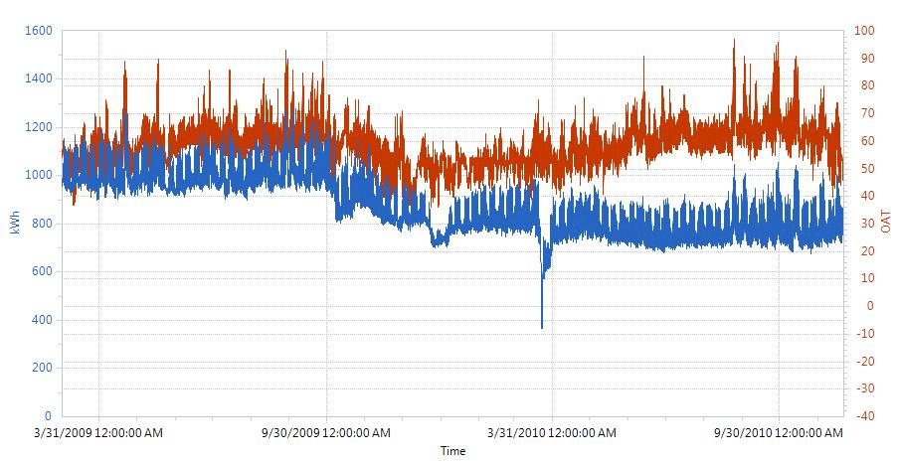

Installation Period (data not used)

Baseline Period

Post-Install Period

Figure 1b. View of Selected Baseline Period Data.

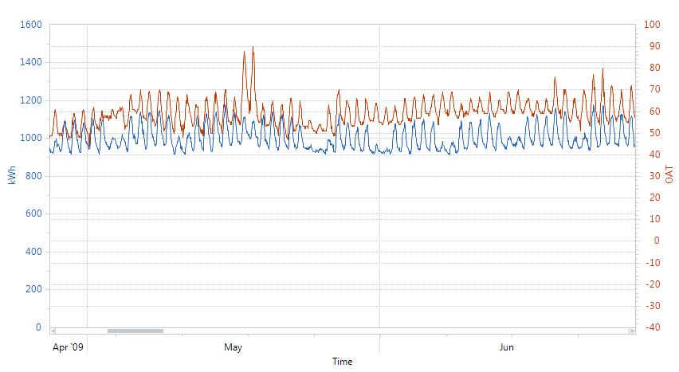

Figure 1c. View of Selected Post-Installation Period Data.

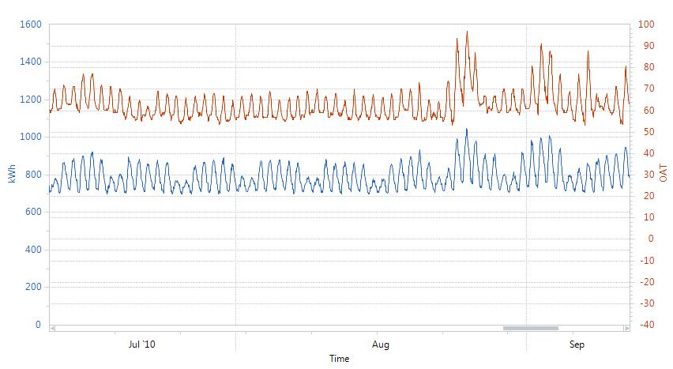

Develop Regression Models

* By examination of Figure 1, both baseline and post-installation period energy use appears to follow regular and predictable patterns. The building’s operation schedule was confirmed to follow a consistent schedule each week, and this is confirmed in the data. In addition, a significant dependency on ambient temperature (outside air temperature - OAT) is also evident in the data.
* A linear regression model[2] using a time of week indicator variable, and a piecewise linear and continuous OAT dependence was chosen to model the hourly energy use for both the baseline and post-installation periods. This model is described mathematically in Appendix A.
* The selected model accounts for the different responses of energy use in different temperature regimes, for example, at low temperatures, electric energy use may increase as the building uses more pump and fan energy, at moderate temperatures, it may be insensitive to temperature, as the temperatures warm, the energy use increases due to the use of cooling systems, and so on.
* The model uses the time of week indicator variable to correct the building’s energy use response to temperature, for example, the energy use in the building when temperatures are 60 degrees °F at 9 am in the morning are much different than when it is 60 degrees F at 6 pm in the evening.
* This model form was programmed into an analysis module of free public domain software called the Universal Translator (UT).[3] The software calculates some goodness-of-fit metrics and allows all dependent, independent, and predicted variables to be exported for analysis.

Baseline Model Development

* The hourly electric energy use data (in kWh) and ambient temperature (in °F) was imported into the UT M&V analysis module, and a linear regression model relating baseline energy use to time of week and temperature was developed using the modeling algorithm described above. A description of the data and model were output from the software:
  + Baseline period start date/time: 3/2/2009 12:00:00 AM
  + Baseline period end date/time: 10/2/2009 12:00:00 AM
  + R²: 0.88, CV(RMSE) = 2.31%
  + Number of data points: 5,135
  + Analysis time interval: Hourly
  + Independent variable: OAT
* Figure 2 shows a month of the baseline period hourly energy use data as well as the baseline model’s predictions.
* Next, the standard error of regression is determined. It was described in the introduction:

${SE}_{\hat{Y}}=\sqrt{\frac{\sum{{({\hat{Y}}_{i}-Y_{i})}^{2}}}{n-k-1}}$ (1)

* The standard error of regression was calculated by exporting the baseline period hourly measured (*Yi*) and predicted values (*Ŷi*) of kWh into a spreadsheet and carrying out equation (1). For the baseline model, n = 5,135 points, k is the number of parameters in the regression equation, which has 168 coefficients for each hour of week parameter, and 6 temperature segments, each representing an additional parameter, plus one constant parameter: n – k - 1 = 168 + 6 + 1 - 1 = 174. Using these values, *SEŶ* = 23.8 kWh. This calculation and the first few rows of the spreadsheet are shown in Table 1.
* The Bias Error is the sum of the residuals. For the baseline model, Bias Error << 0.005%. The baseline model meets the required IPMVP criteria.

Table 1. Baseline Model Analysis Spreadsheet.



* + The model residuals are examined to determine whether any patterns exist that indicate potential modeling errors. The residuals are plotted against the predicted values in Figure 3. Figure 3 shows that the residuals do not exhibit a pattern and appear randomly spaced about the 0 axis. This indicates the independent variables and model form explain most of the variation in the energy use variable.
  + The time of week and temperature model is known to have autocorrelation, the degree of which can be evaluated with the Durbin-Watson test. The presence of autocorrelation means that confidence and prediction intervals estimated using the ordinary least squares approach may underestimate the actual intervals. This discussion is included in Appendix B.

**Figure 2. Baseline Period Data and Model Predictions.**

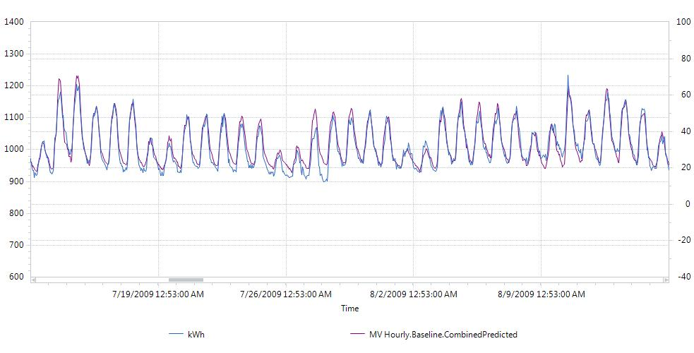

**Figure 3. Baseline Model Residuals versus Predicted Values.**



Post-Installation Model Development

* The same process was used to develop the post-installation energy use model as completed for the development of the baseline model. The description of the post-installation data and model were output from the software:
  + Post-Installation period start date/time: 5/15/2010 12:00:00 AM
  + Post-Installation period end date/time: 11/20/2010 12:00:00 AM
  + R²: 0.91, CV(RMSE) = 2.60%
  + Number of data points: 4,537
  + Analysis time interval: Hourly
  + Independent variable: OAT
* Figure 4 shows a month of the post-installation period hourly energy use data as well as the post-installation model’s predictions.
* The standard error of regression is determined.
  + The standard error of regression was calculated by exporting the post-installation period hourly measured (*Yi*) and predicted values (*Ŷi*) of kWh into a spreadsheet and carrying out equation (1). For the post-installation model, n = 4,537 points, k = 174 as before. Using these values, *SEŶ* = 21.0 kWh. This calculation and the first few rows of the spreadsheet are shown in Table 2.
  + The Bias Error is the sum of the residuals. For the post-installation model, Bias Error << 0.005%. The post-installation model meets the required IPMVP criteria.

Table 2. Post-Installation Model Analysis Spreadsheet.



* + The model residuals are shown in Figure 5, which shows that the residuals do not exhibit a pattern and appear randomly spaced about the 0 axis, indicating that the independent variables and model form explain most of the variation in the energy use variable.
  + As in the baseline case, the time of week and temperature model is known to have autocorrelation. A discussion on autocorrelation is included in Appendix B.

**Figure 4. Post-Installation Period Data and Model Predictions.**

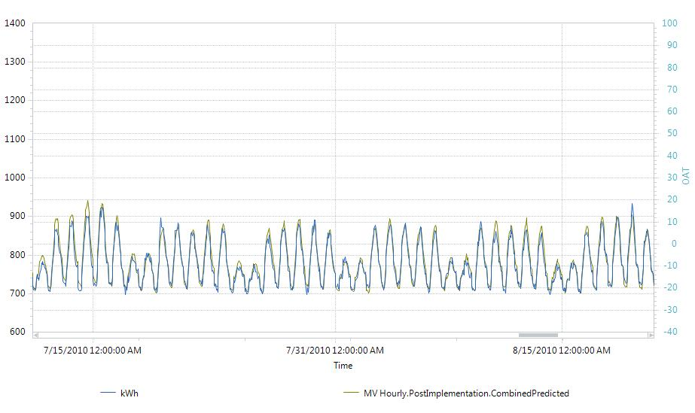

**Figure 5. Post-Installation Model Residuals versus Predicted Values.**



6. Savings and Uncertainty

* Non-routine adjustments, or adjustments to energy use based on unexpected increases or decreases in load were not detected in the building during the baseline or post-installation monitoring periods. The savings will be determined based only on routine adjustments in this example.
* Annual savings estimates were derived based on adjustments of baseline and post-installation energy use to typical meteorological year (TMY) weather conditions for this climate zone. The date and time, and OAT (dry-bulb) values for each hour in the TMY dataset were input into the UT software M&V analysis module. The adjusted baseline energy use, and adjusted post-installation energy use under TMY conditions was determined. Figure 6 shows the adjusted baseline energy use (purple), adjusted post-installation energy use (green), and TMY ambient temperatures (red).

**Figure 6. Baseline and Post-Installation Energy Use under TMY Conditions**

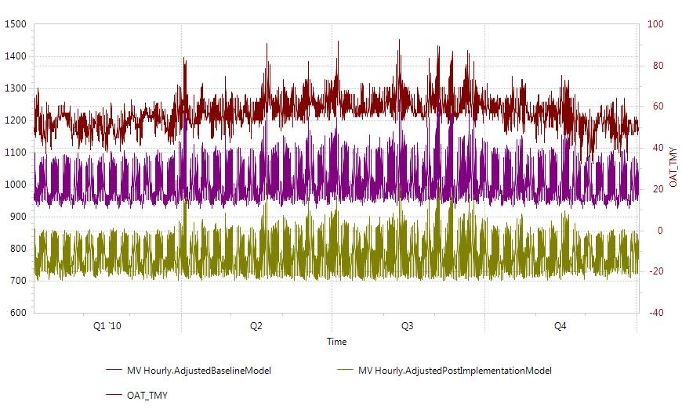

* The normalized savings is the difference between the adjusted (to TMY) baseline energy use and the adjusted (to TMY) post-installation energy use.

Savings = kWhadj-base – kWhadj-post

* + Where:
    - kWhadj-base = annual baseline kWh under TMY conditions
    - kWhadj-post = annual post-installation kWh under TMY conditions
  + These values were found after exporting the adjusted baseline and post-installation energy use to a spreadsheet and performing the calculations. Table 3 provides the first few rows of the data in a spreadsheet used to calculate savings and uncertainty. Savings = 8,824,822 – 6,866,654 = 1,958,168 kWh
* An estimation for the range of possible values for each prediction *Ŷ* in the baseline and post-installation periods can be computed using:



Where:

* *Ŷ* is the predicted value of energy from the regression model
* *t* is the value obtained from the t-tables, for 95% confidence, *t* = 1.96
* *SEŶ* is the standard error of the estimate (prediction).

Table 3. First few rows of spreadsheet showing calculation of normalized savings and estimation of savings uncertainty.



* For the average baseline model prediction of energy use under TMY (or any) conditions, the 95% prediction interval is 1.96 × the Standard Error of Regression (SE). The average baseline energy consumption associated with the prediction interval is the total baseline consumption divided by the number of hourly intervals: 8760. This means that the uncertainty in the adjusted baseline annual consumption is: $8760×\left(t×{SE}_{b}\right)$, or 8760 × 46.6 = 408,636 kWh, which is 4.6% of adjusted baseline annual consumption.
* Similarly, the uncertainty in the adjusted post-installation annual consumption is: $8760×\left(t×{SE}_{b}\right)$, or 8760 × 43.1 = 377,731 kWh, which is 5.5% of adjusted post-installation annual consumption.
* Once annual baseline and post-installation consumption have been estimated, the savings and savings uncertainty may be calculated. Savings uncertainty is calculated as the square root of the sum of the squared values of baseline and post-installation annual consumption. Savings Uncertainty = $\sqrt{{408,636}^{2}+{377,731}^{2}}$ = 556,475 kWh, which is 28.4% of the annual savings.
* Savings is fully stated as 1,958,168 ± 278,238 kWh at the 95% confidence level.
* This savings is well within the University’s uncertainty requirements.
* Analysis using daily data is provided in Appendix C.

# Appendix A: Description of Time-of-Week and Temperature Model

* The following description is paraphrased from the Matthieu article,[4] where a more comprehensive description may be found.
  + A facility’s electric energy use is a function of ambient temperature and time of week, so both are included in the model.
  + Each week is divided into hourly intervals (indexed by i), with the first interval from midnight to 1 am Monday morning, the second from 1 am to 2 am, and so on for the 168 hours each week. A different regression coefficient for each time of week indicator variable, αi allows each time-of-week to have a different predicted load.
  + Energy response to temperature in a building is non-linear but may be modeled as continuous and piecewise linear. At low temperatures, electric energy use may increase due to more use of heating system equipment such as pumps and fans. In moderate temperatures, the building does not require heating and cooling and therefore energy use is not sensitive to temperature. At warm temperatures, energy use increases with increasing temperature due to use of cooling system equipment. At the highest temperatures, energy use may be again insensitive to temperature as cooling equipment has reached its maximum load. There may be multiple regimes of energy response to temperature.
  + The piecewise linear and continuous temperature at time *t*, *T(ti)* (which occurs at time of week interval *i*) is broken down into a number of component temperatures, *Tc.j(ti)*, with *j* = 1 to *ns* (*ns* being the number of line segments, usually no more than 10 to avoid overfitting). Each *Tc.j(ti)* is multiplied by *βj* and then summed to determine the temperature dependent load.
  + Boundary values of the temperature segments are defined by *Bk* (*k* = 1…*ns*-1). And component temperatures are determined with the following algorithm (assuming *ns* = 6):
    - If *T*(*ti*) > *B1*, then *Tc,1*(*ti*) = *B1*. Otherwise, *Tc,1*(*ti*) = *T*(*ti*) and *Tc,m*(*ti*) = 0 for *m* = 2 … 6 and algorithm is ended.
    - For *n* = 2 … 4, if *T*(*ti*) > *Bn*, then *Tc,n*(*ti*) = *Bn* – *Bn-1*. Otherwise, *Tc,n*(*ti*) = *T*(*ti*) – *Bn-1* and *Tc,m*(*ti*) = 0 for *m* = (*n* + 1) … 6 and algorithm is ended.
    - If *T*(*ti*) > *B5*, then *Tc,5*(*ti*) = *B5* – *B4* and *Tc,6*(*ti*) = *T*(*ti*) – *B5*.
  + The building is anticipated to have a different response to temperature in occupied periods versus unoccupied periods. The occupied load is estimated using the following equation:
$${\hat{E}}_{o}\left(t_{i},T\left(t_{i}\right)\right)=α_{i}+\sum_{j=1}^{n}{β_{j}T_{c,j}(t_{i})}$$

* Unoccupied loads are expected to have a single temperature parameter, since the building is expected to operate without sensitivity to temperature at night. Unoccupied load is modeled with the following equation:
$${\hat{E}}_{u}\left(t_{i},T\left(t_{i}\right)\right)=α_{i}+β_{u}T(t_{i})$$

* The parameters *αi*, for *i* = 1 to 168, *βj* for *j* = 1 to n and *βu* are estimated using the data from the baseline and post-installation periods with ordinary least squares.
* The model produces residuals that are autocorrelated and heteroscedastic, and the regression parameters *αi* and *βj* are correlated. This means that the standard errors associated with each regression parameter underestimates their level of uncertainty. However, uncertainty on the load predictions can be approximated with the standard error, which can be computed at each interval *i*.
* This algorithm has been programmed into a free public domain desktop software package.[5] The software allows the user to input streams of date and time stamped energy use and ambient temperature data, manipulate parameters and develop linear regression models with time-of-week indicators and ambient temperature as independent variables.
* This algorithm has been programmed into an M&V analysis module of a free public domain desktop software package[6] called Universal Translator. The software allows the user to input streams of date and time stamped energy use and ambient temperature data, manipulate parameters and develop linear regression models with time-of-week indicators and ambient temperature as independent variables. The software calculates the *αi* and *βj* parameters according to the user-specified analysis time interval (e.g. hourly or daily) and number of line segments for the piecewise continuous temperature dependence. Note that there are 168 coefficients for hourly time intervals, and 7 coefficients for daily time intervals, in addition to the specified number of line segments that make up all the terms in the resulting regression equation.
* The software does not export the final form of the energy models it develops, however it allows all analysis data to be exported. This data is analyzed to determine the goodness of fit and accuracy of the baseline and post-installation models prior to calculating

# Appendix B: Model Autocorrelation and Cross Validation

* The Durbin-Watson statistic indicates the degree of autocorrelation. The statistic is calculated as:
 $$d=\frac{\sum_{t=2}^{n}{{\left(e_{t}-e_{t-1}\right)}^{2}}}{\sum_{t=1}^{n}{e_{t}^{2}}}$$

 + Where:
    - e = *Ŷi* – *Yi*, the residual at time *i*
    - n = number of data points
* If d is less than 1, significant autocorrelation exists in the data and uncertainties may be underestimated using standard errors calculated as described above. For the baseline model developed in the case study, d = 0.31.
* A cross-validation method was used to evaluate the prediction errors of the baseline model. Holding out one week of data for each month in the baseline period, the remaining data was used to develop a model. This model was used to predict the energy use during the held-out periods, and the prediction errors were determined by comparing model predictions with actual data. Figure B1 shows the held-out periods of data and Figure B2 provides a chart of the prediction errors of the held-out data. It is evident that Figure B2 shows a similar distribution of error as in Figure 3. The standard error calculated from the held-out data was 23.5 kWh, which is very close to the 23.8 kWh standard error estimated for the baseline model.

**Figure B1. Baseline Held-Out Periods**

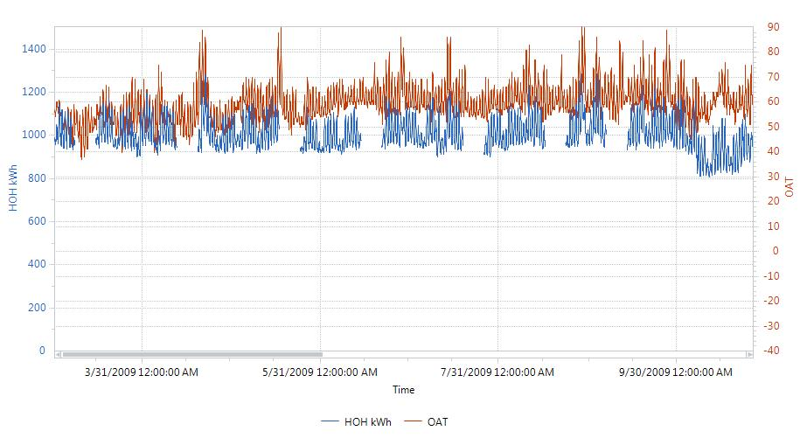

**Figure B2. Distribution of Hold-Out Period Prediction Errors.**



# Appendix C: Analysis Using Daily Data

In this appendix, the same project and data were used, and the same procedures were followed, except that the data were re-sampled to daily time intervals before beginning analysis. Electric energy use data were summed over each 24 hour period of each day, and outside air temperatures (OAT) were averaged over the entire day. The daily data is shown in Figure C1. Note that other methods of re-sampling OAT data are possible and may improve model goodness-of-fit, however these methods were not used here.

Figure C1. Baseline through Post- Installation Electric Energy Use and Ambient Temperature Data

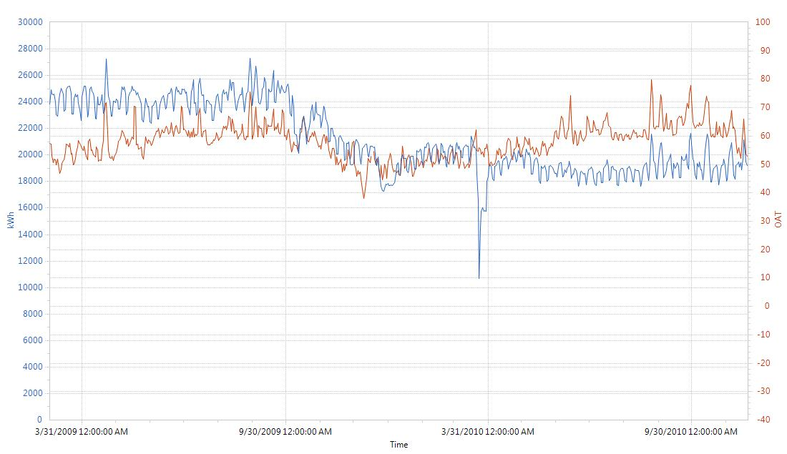

Post-Install Period

Baseline Period

Installation Period (data not used)

Baseline Model Development

* The daily electric energy use data (in kWh) and ambient temperature (in °F) was imported into the UT M&V analysis module, and a linear regression model relating baseline energy use to time of week and temperature was developed using the modeling algorithm described above. A description of the data and model were output from the software:
  + Baseline period start date/time: 3/2/2009 12:00:00 AM
  + Baseline period end date/time: 10/2/2009 12:00:00 AM
  + R²: 0.79, CV(RMSE) = 1.63%
  + Number of data points: 214
  + Analysis time interval: Daily
  + Independent variable: OAT
* Figure C2 shows the baseline period daily energy use data as well as the baseline model’s predictions.
* Next, the standard error of regression is determined:

${SE}_{\hat{Y}}=\sqrt{\frac{\sum{{({\hat{Y}}_{i}-Y_{i})}^{2}}}{n-k-1}}$ (C1)

* The standard error of regression was calculated by exporting the baseline period daily measured (*Yi*) and predicted values (*Ŷi*) of kWh into a spreadsheet and carrying out equation (C1). For the baseline model, n = 214 points, k is the number of parameters in the regression equation, which has 7 coefficients for each day of week parameter, and 6 temperature segments, each representing an additional parameter, plus one constant parameter: n – k - 1 = 7 + 6 + 1 - 1 = 13. Using these values, *SEŶ* = 408.4 kWh. This calculation and the first few rows of the spreadsheet are shown in Table C1.
* The Bias Error << 0.005%. The baseline model meets the required IPMVP criteria.

Table C1. Baseline Model Analysis Spreadsheet.



* + The model residuals are examined to determine whether any patterns exist that indicate potential modeling errors. The residuals are plotted against the predicted values in Figure C3. Figure C3 shows that the residuals do not exhibit a pattern and appear randomly spaced about the 0 axis. This indicates the independent variables and model form explain most of the variation in the energy use variable.

**Figure C2. Baseline Period Data and Model Predictions.**

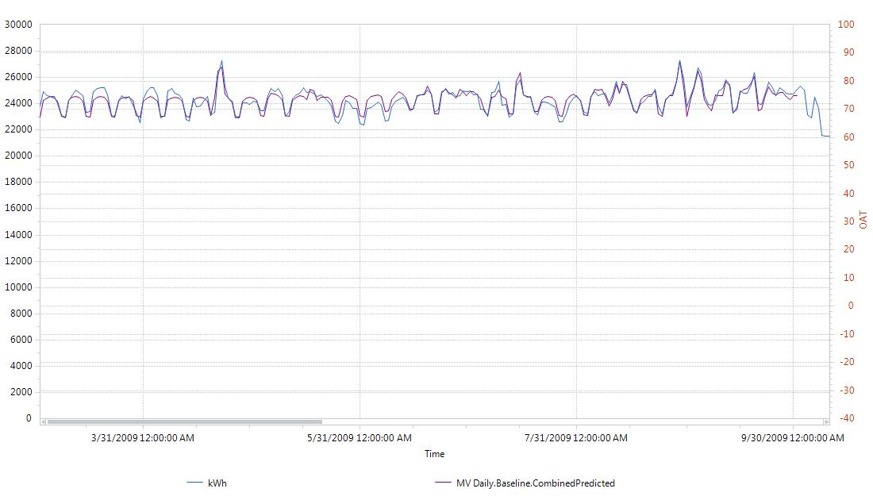

**Figure C3. Baseline Model Residuals versus Predicted Values.**



Post-Installation Model Development

* The same process was used to develop the post-installation energy use model as completed for the development of the baseline model. The description of the post-installation data and model were output from the software:
  + Post-Installation period start date/time: 5/15/2010 12:00:00 AM
  + Post-Installation period end date/time: 11/20/2010 12:00:00 AM
  + R²: 0.79, CV(RMSE) = 1.94%
  + Number of data points: 189
  + Analysis time interval: Daily
  + Independent variable: OAT
* Figure C4 shows the post-installation period daily energy use data as well as the post-installation model’s predictions.
* The standard error of regression is determined.
  + The standard error of regression was calculated by exporting the post-installation period hourly measured (*Yi*) and predicted values (*Ŷi*) of kWh into a spreadsheet and carrying out equation (1). For the post-installation model, n = 189 points, k = 13 as before. Using these values, *SEŶ* = 381.1 kWh. This calculation and the first few rows of the spreadsheet are shown in Table C2.
  + The Bias Error << 0.005%. The post-installation model meets the required IPMVP criteria.

Table C2. Post-Installation Model Analysis Spreadsheet.



* The model residuals are shown in Figure C5, which shows that the residuals do not exhibit a pattern and appear randomly spaced about the 0 axis, indicating that the independent variables and model form explain most of the variation in the energy use variable.

**Figure C4. Post-Installation Period Data and Model Predictions.**

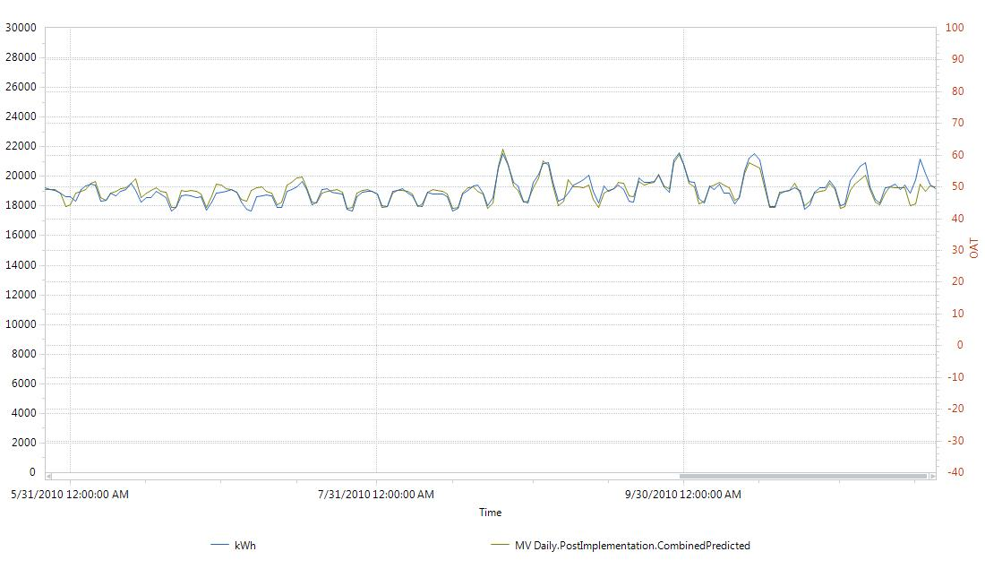

**Figure C5. Post-Installation Model Residuals versus Predicted Values.**



Savings and Uncertainty

* Annual savings estimates were derived based on adjustments of baseline and post-installation energy use to typical meteorological year (TMY) weather conditions for this climate zone. Outside air dry-bulb temperatures in the TMY data set were averaged over each day. The date and OAT (dry-bulb) values for each day in the re-sampled TMY dataset were input into the UT software M&V analysis module. The adjusted baseline energy use, and adjusted post-installation energy use under TMY conditions was determined. Figure C6 shows the adjusted baseline energy use (purple), adjusted post-installation energy use (green), and TMY ambient temperatures (red).

**Figure C6. Baseline and Post-Installation Energy Use under TMY Conditions**

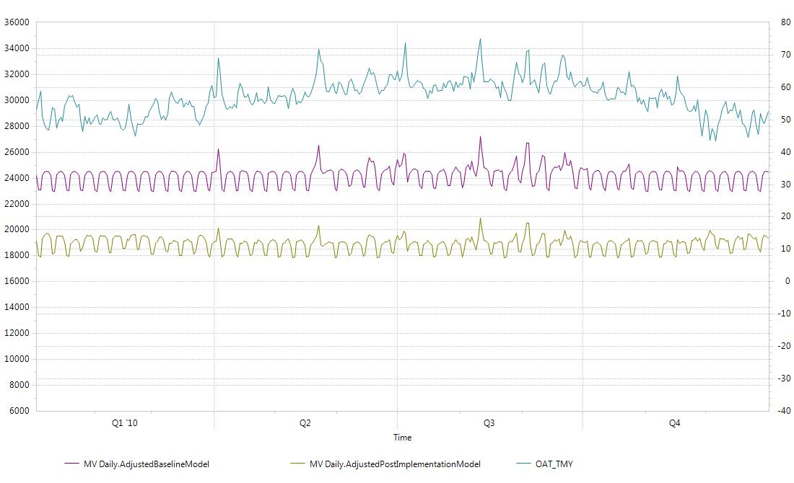

* The normalized savings is the difference between the adjusted (to TMY) baseline energy use and the adjusted (to TMY) post-installation energy use.

Savings = kWhadj-base – kWhadj-post

* + Where:
    - kWhadj-base = annual baseline kWh under TMY conditions
    - kWhadj-post = annual post-installation kWh under TMY conditions
  + These values were found after exporting the adjusted baseline and post-installation energy use to a spreadsheet and performing the calculations. Table C3 provides the first few rows of the data in a spreadsheet used to calculate savings and uncertainty. Savings = 8,810,432 – 6,890,776 = 1,919,656 kWh
* An estimation for the range of possible values for each prediction *Ŷ* in the baseline and post-installation periods can be computed using:



Where:

* *Ŷ* is the predicted value of energy from the regression model
* *t* is the value obtained from the t-tables, for 95% confidence, *t* = 1.96
* *SEŶ* is the standard error of the estimate (prediction).

Table . First few rows of spreadsheet showing calculation of normalized savings and estimation of savings uncertainty.



* For the average baseline model prediction of energy use under TMY (or any) conditions, the 95% prediction interval is 1.96 × the Standard Error of Regression (SE). The average baseline energy consumption associated with the prediction interval is the total baseline consumption divided by the number of hourly intervals: 365. This means that the uncertainty in the adjusted baseline annual consumption is: $365×\left(t×{SE}_{b}\right)$, or 365 × 46.6 = 292,169 kWh, which is 3.3% of adjusted baseline annual consumption.
* Similarly, the uncertainty in the adjusted post-installation annual consumption is: $365×\left(t×{SE}_{b}\right)$, or 365 × 43.1 = 273,140 kWh, which is 4.0% of adjusted post-installation annual consumption.
* Once annual baseline and post-installation consumption have been estimated, the savings and savings uncertainty may be calculated. Savings uncertainty is calculated as the square root of the sum of the squared values of baseline and post-installation annual consumption. Savings Uncertainty = $\sqrt{{292,169}^{2}+{273,140}^{2}}$ = 399,960 kWh, which is 20.8% of the annual savings.
* Savings is fully stated as 1,919,656 ± 199,980 kWh at the 95% confidence level.

1. Matthieu, J.L., P.N. Price, S. Kiliccote, and M.A. Piette, “Quantifying Changes in Building Electricity Use, With Application to Demand Response,” IEEE Transactions on Smart Grid, 2:507-518, 2011
2. Mathieu, ibid.
3. M&V Analysis Module in PG&E’s Universal Translator version 3, available at www.utonline.org.
4. Matthieu, J.L., P.N. Price, S. Kiliccote, and M.A. Piette, “Quantifying Changes in Building Electricity Use, With Application to Demand Response,” IEEE Transactions on Smart Grid, 2:507-518, 2011
5. M&V Analysis Module in version 3 of Universal Translator. Available at www.utonline.org.
6. M&V Analysis Module in version 3 of Universal Translator. Available at www.utonline.org.